**UNIT -II**

**Types of Errors:**

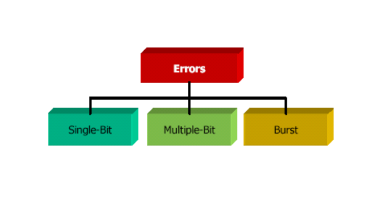

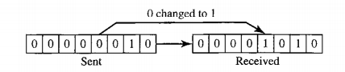

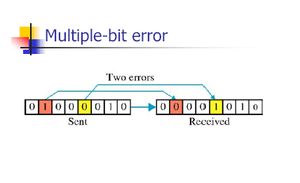

Burst Error:

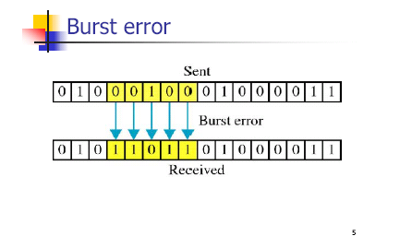

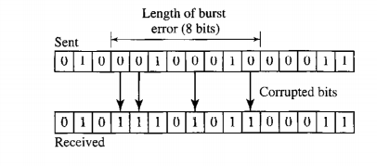

**Redundancy:**

Extra bits sent with our data

**Detection Vs Correction:**

**Error Detection:**

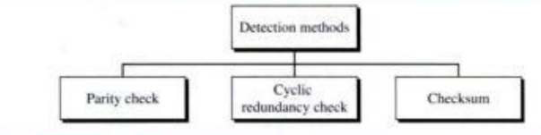

**Error Correction:**

**1.Retransmission**

**2. Forward Error Correction**

1. **Parity:a)Simple Parity**

**b) Two-dimensional Parity**

1. **Simple Parity:**

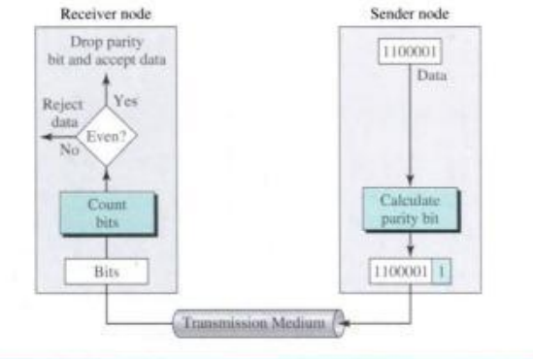

**2-Dimensional Parity:**

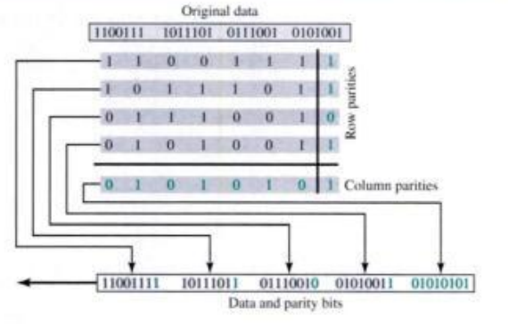

1. **Cyclic Redundancy Check(CRC):**

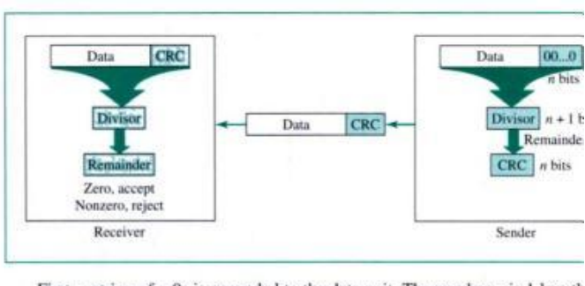

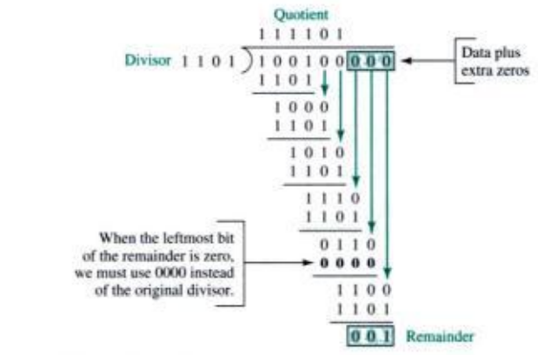

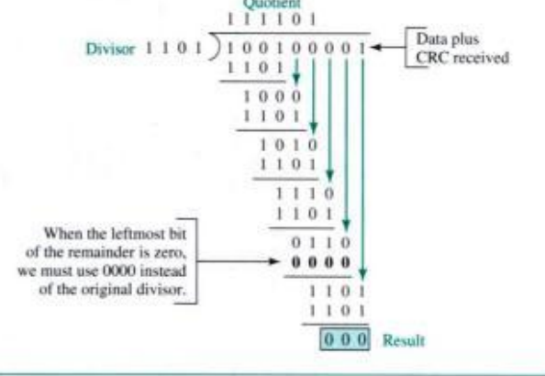

Data Link Layer- Data Link Control-Flow Control + Error Control

Error Control-Error detection & Retransmission.

Any time when error detected, retransmission occurs- Automatic Repeat Request(ARQ).

3 common flow and error control mechanisms:

1. Stop-and-wait ARQ
2. Go-back-N ARQ
3. Selective Repeat ARQ.
4. Stop-and-wait ARQ:

a)Normal Operation:

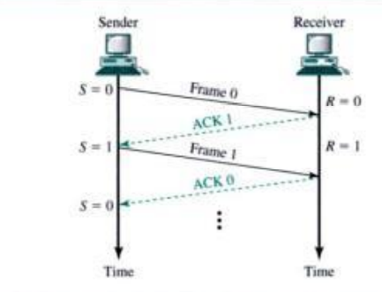

b) Lost or damaged frame:

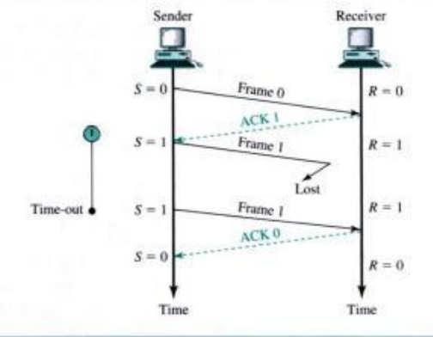

c) Lost Acknowledgement:

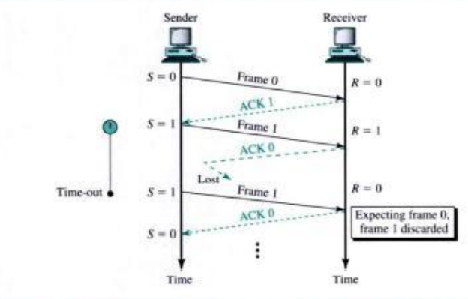

d) Delayed Acknowledgement:

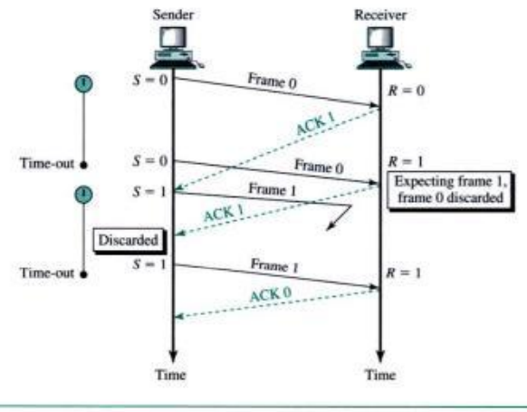

Stop-and-wait is unidirectional.

**2)Go-Back-N ARQ:**

**Sequence Numbers:**

**If the header of the frame allows m bits, range of sequence number will be 0- 2m – 1.**

**Sender sliding window:**

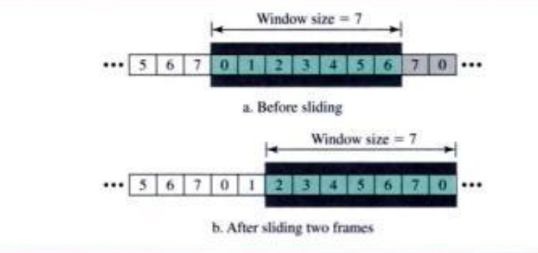

**Receiver Sliding window:**

**Window size=1**

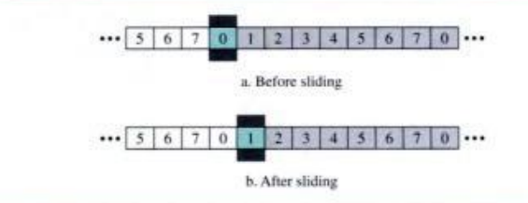

**Control Variables:**

**Sender has 3 control variables:**

**S,Sf and Sl**

S-variable holds the sequence number of recently send frame.

SF-holds the seq. no. of the 1st frame in the window

SL-holds the seq.no. of last frame.

Size of the window W=Sl-Sf+1

Receiver Control Variables:-R-holds the seq. no. of the frame it expects to receive.

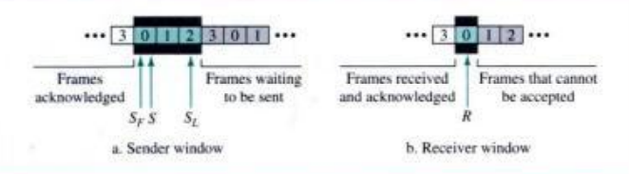

**Timers:**

Sender side-timers.

**Acknowlegement:**

**Operations:**

**Normal Operation:**

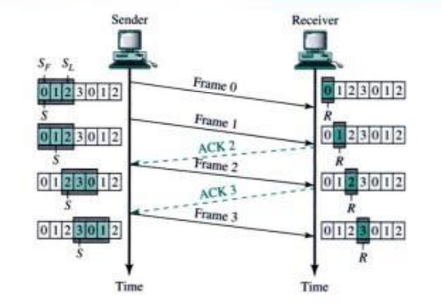

**Damaged or Lost Frame:**

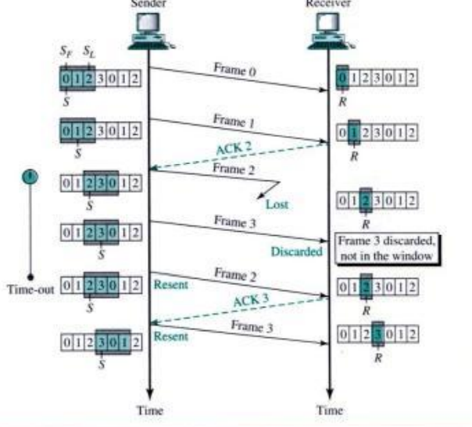

**Damaged or Lost Acknowledgement:**

**Delayed Acknowledgement:**

**Selective-repeat ARQ:**

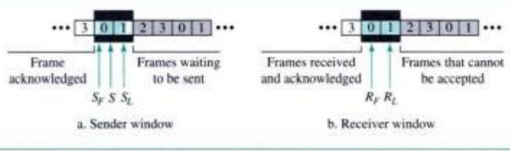

**Operation:**

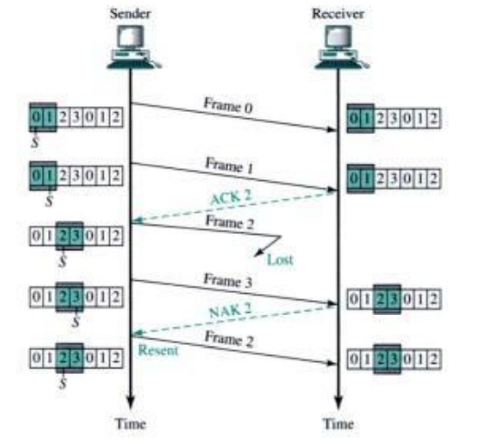

**HDLC:**

**2 modes:**

**a)NRM(Normal Response Mode)**

**b)ABM(Asynchronous Balanced Mode)**

**Normal Mode**

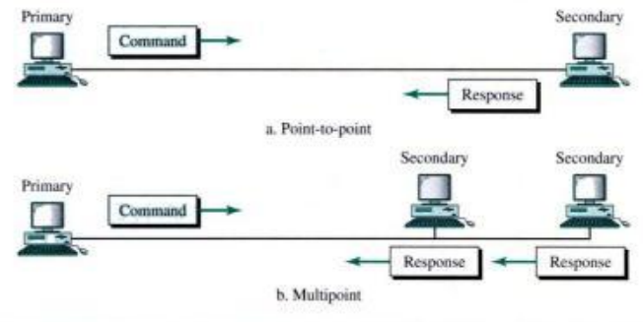

**ABM:**

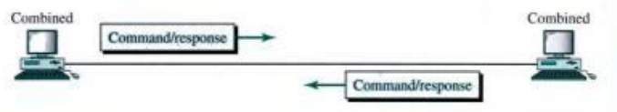

**3 types of frames:**

1. **I-frame(Information frames)**
2. **S-frame(Supervisory frames)**
3. **U-frame(Unnumbered frames)**

**HDLC Frame Format:**

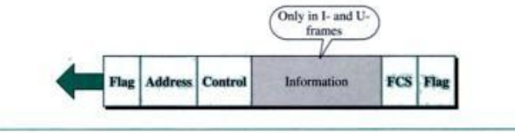

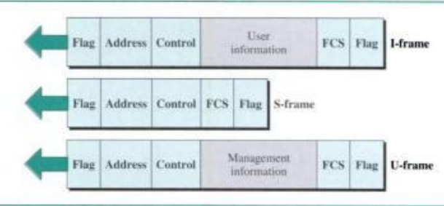

**I-Frame:**

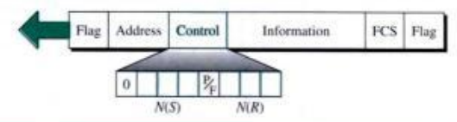

**S-frame:**

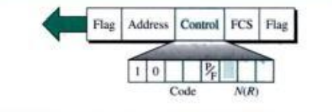

**4 types of S-frames:**

1. **RR**
2. **RNR**
3. **REJ**
4. **SREJ**

**U-frame:**

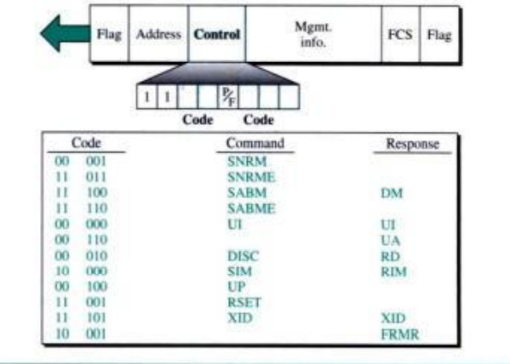

**IEEE 802.3.**

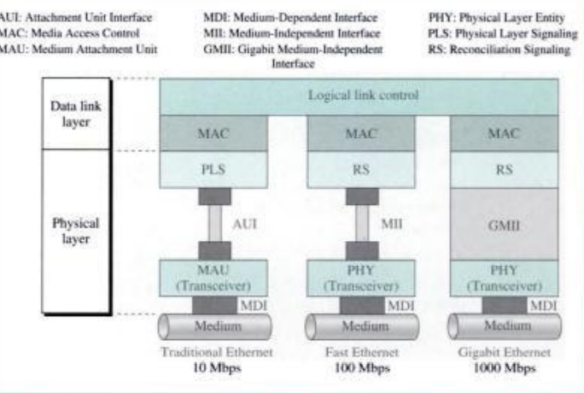

**Data Link Layer:**

**a)Logical Link Control(LLC)**

**b) Medium Access Control(MAC)**

**Traditional Ethernet:**

**10Mbps.**

**Access to the network-CSMA/CD**

**IEEE 802.11:**

**2 kinds of service:**

1. **Basic Service set(BSS)**
2. **Extended service set(ESS)**

**BSS:**

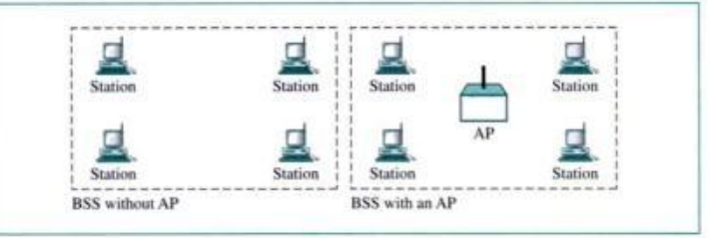

**ESS:**

